.

<(NAME) Project: (Workstream NAME)>

<Title: 3 Layer (Base, Design and Product) Specification Template>

<Version>.<Revision>.<Errata>

**Modular (Base, Design and Product) Specification**

Effective XXXX, 2024

Author: <Primary>

Author: <Secondary, etc. Delete if unnecessary>

# Version History

| DELETE THIS BLOCK |
| --- |
| ***INSTRUCTIONS FOR ALL FOLLOWING SECTIONS:***   * + *This section is only required if there is a directly linked preceding document which means this is a revision to the original document. If this is a completely new version (original) you may delete this page.*   + *The revisions in the populated table below apply to the template, please start from a blank table for your contribution.*   + *See the OCP Release Nomenclature Guidelines for additional information.* |

Note, refer to the OCP Contribution Versions, Revisions and Errata best practices documentation. Generally speaking, Versions and revisions are made to this document and logged here. Errata is a separate document such that the contribution specification document it refers to was not revised. Ex: Version 1, Errata E1

| **Date** | **Version #** | **Author** | **Description** |
| --- | --- | --- | --- |
| 01 JAN 24 | 1.0.0 | Bijan Nowroozi/Michael Shill/Rob Coyle | Initial Release |
| 17 JUN 24 | 1.0.1 | Bijan Nowroozi | Modified title page to include project information and added some context on p.10 openness tenet, Appendix C updates |
| 30 AUG 24 | 1.1.0 | Bijan Nowroozi | Added usage note and compliance sections |
| 08 SEP 23 | 1.2 | Bijan Nowroozi | Changed some of the sustainability text |
| 06 NOV 23 | 1.3 | Bijan Nowroozi | Terminology changes and edits for clarity |
| 30 SEP 24 | 1.4 | Bijan Nowroozi | Added usage note and compliance sections, updated numbering |
| 11 NOV 24 | 1.5 | Bijan Nowroozi | Reflected New License, cleaned up instructional text boxes, tenets |

# 

# Current Template Version:

3 Layer (Base, Design and Product) Specification Template V1.5.0

**Table of Contents**

**Version History 2**

**Current Template Version: 3**

**1. License 8**

1.1. Open Web Foundation (OWF) CLA 8

**1. Acknowledgements 9**

**2. Compliance with OCP Tenets 10**

1.1. Openness 10

1.2. Efficiency 11

1.3. Impact 11

1.4. Scale 11

1.5. Sustainability 11

**3. Scope 13**

3.1. Usage 13

3.2. Base Specification Layer 13

3.3. Design Specification Layer 14

3.4. Product Specification Layer 15

**4. Overview 17**

**5. Base Specifications 18**

5.1. Description 18

5.2. Goals and Vision 18

5.3. User Requirements/User Stories 18

5.4. Solution Architecture 18

5.5. Functional Requirements 18

5.5.1. Environmental Regulatory Compliance and Requirements 18

5.6. Non-Functional Requirements 19

5.7. Features 19

**5.8. Physical Requirements 19**

**5.9. Mechanical 20**

5.9.1. Rack Compatibility 20

5.9.2. General Requirements 20

**5.10. Electrical Requirements 21**

**5.11. Thermal Design Requirements 21**

**5.12. Onboard Power 22**

5.13. Interface Requirements 22

5.13.1. Signal List 23

5.13.2. Rear Side Power, I/O, Expansion Board and Midplane Subsystems 23

5.14. Performance Requirements 24

5.15. Security Requirements 24

**5.16. Hardware Management 25**

5.17. Constraints 26

5.18. Test and Validation Requirements 26

**Provide the concepts for testing and validation of this solution. 26**

5.19. External Software/Firmware Support (Strongly recommended) 26

**5.20. Compliance 26**

**5.21. Arm SystemReady (only for Arm-based Systems) Requirement 28**

5.22. Repository Location 28

5.23. Prescribed Materials 28

5.24. References (recommended) 29

**6. Design Specifications 29**

6.1. Description 29

6.2. User Requirements/User Stories 29

6.3. Solution Architecture 30

6.4. Supported Functions 30

6.4.1. Environmental Regulatory Compliance and Design 30

6.5. Non-Functional Requirements 31

6.6. Features 31

6.7. Physical Design 31

6.8. Mechanical Design 32

6.8.1. Rack Compatibility 32

6.8.2. General Requirements 32

6.9. Electrical Requirements 33

6.10. Thermal Design Requirements 33

6.11. Onboard Power 34

6.12. Interfaces 34

6.12.1. Signal List 35

6.12.2. Rear Side Power, I/O, Expansion Board and Midplane Subsystems 35

6.13. Performance 36

6.14. Security 36

**6.15. Hardware Management 37**

6.16. Constraints 38

6.17. Test and Validation 38

**Provide the concepts for testing and validation of this solution. 38**

6.18. External Software/Firmware Support (Strongly recommended) 38

6.19. Compliance 38

6.20. Arm SystemReady (only for Arm-based Systems) Requirement 39

6.21. Repository Location 40

6.22. Prescribed Materials 40

6.23. References (recommended) 40

**7. Product Specifications 41**

7.1. Description 41

7.2. User Requirements/User Stories 41

7.3. Solution Architecture 41

7.4. Supported Functions 41

7.4.1. Environmental Regulatory Compliance and Design 41

7.5. Non-Functional Requirements 42

7.6. Features 42

7.7. Physical Design 43

7.8. Mechanical Design 43

7.8.1. Rack Compatibility 44

7.8.2. General Requirements 44

7.9. Electrical Requirements 44

7.10. Thermal Design Requirements 45

7.11. Onboard Power 45

7.12. Interfaces 46

7.12.1. Signal List 46

7.12.2. Rear Side Power, I/O, Expansion Board and Midplane Subsystems 47

7.13. Performance 47

7.14. Security 48

**7.15. Hardware Management 48**

7.16. Constraints 49

7.17. Test and Validation 50

**Provide the concepts for testing and validation of this solution. 50**

7.18. External Software/Firmware Support (Strongly recommended) 50

7.19. Compliance 50

7.20. Arm SystemReady (only for Arm-based Systems) Requirement 51

7.21. Repository Location 52

7.22. Prescribed Materials 52

7.23. References (recommended) 52

**Appendix A - Checklist for Steering Committee (SC) approval of this Specification (to be completed by contributor(s) of this Spec) 53**

**Appendix B-__ <supplier name> - OCP Supplier Information and Hardware Product Recognition Checklist 54**

**Appendix C - Contribution Process FAQs 56**

# 

# License

THE UPDATED DEFAULT CONTRIBUTOR LICENSE AGREEMENT (CLA) IS [**OWFa 0.9**](https://146a55aca6f00848c565-a7635525d40ac1c70300198708936b4e.ssl.cf1.rackcdn.com/images/ed0befaf86bee2568ad720ff4a9a554d1f4260f7.pdf). PLEASE VERIFY THE CORRECT CLA/FSA IS USED AND EXECUTED FOR THIS CONTRIBUTION.

## Open Web Foundation (OWF) CLA

Contributions to this Specification are made under the terms and conditions set forth in **Modified Open Web Foundation Agreement 0.9 (OWFa 0.9)**. (As of October 16, 2024) (“Contribution License”) by:

**[Contributor Name(s) or Company name(s)]**

Usage of this Specification is governed by the terms and conditions set forth in **Modified OWFa 0.9 Final Specification Agreement (FSA)** (As of October 16, 2024) **(“Specification License”).**

You can review the applicable Specification License(s) referenced above by the contributors to this Specification on the OCP website at <https://www.opencompute.org/contributions/templates-agreements>.

​​For actual executed copies of either agreement, please contact OCP directly.

**Notes**:

The above license does not apply to the Appendix or Appendices. The information in the Appendix or Appendices is for reference only and non-normative in nature.

NOTWITHSTANDING THE FOREGOING LICENSES, THIS SPECIFICATION IS PROVIDED BY OCP "AS IS" AND OCP EXPRESSLY DISCLAIMS ANY WARRANTIES (EXPRESS, IMPLIED, OR OTHERWISE), INCLUDING IMPLIED WARRANTIES OF MERCHANTABILITY, NON-INFRINGEMENT, FITNESS FOR A PARTICULAR PURPOSE, OR TITLE, RELATED TO THE SPECIFICATION. NOTICE IS HEREBY GIVEN, THAT OTHER RIGHTS NOT GRANTED AS SET FORTH ABOVE, INCLUDING WITHOUT LIMITATION, RIGHTS OF THIRD PARTIES WHO DID NOT EXECUTE THE ABOVE LICENSES, MAY BE IMPLICATED BY THE IMPLEMENTATION OF OR COMPLIANCE WITH THIS SPECIFICATION. OCP IS NOT RESPONSIBLE FOR IDENTIFYING RIGHTS FOR WHICH A LICENSE MAY BE REQUIRED IN ORDER TO IMPLEMENT THIS SPECIFICATION. THE ENTIRE RISK AS TO IMPLEMENTING OR OTHERWISE USING THE SPECIFICATION IS ASSUMED BY YOU. IN NO EVENT WILL OCP BE LIABLE TO YOU FOR ANY MONETARY DAMAGES WITH RESPECT TO ANY CLAIMS RELATED TO, OR ARISING OUT OF YOUR USE OF THIS SPECIFICATION, INCLUDING BUT NOT LIMITED TO ANY LIABILITY FOR LOST PROFITS OR ANY CONSEQUENTIAL, INCIDENTAL, INDIRECT, SPECIAL OR PUNITIVE DAMAGES OF ANY CHARACTER FROM ANY CAUSES OF ACTION OF ANY KIND WITH RESPECT TO THIS SPECIFICATION, WHETHER BASED ON BREACH OF CONTRACT, TORT (INCLUDING NEGLIGENCE), OR OTHERWISE, AND EVEN IF OCP HAS BEEN ADVISED OF THE POSSIBILITY OF SUCH DAMAGE.

# Acknowledgements

The Contributors of this Specification would like to acknowledge the following for their feedback:

List all companies or individuals who may have assisted you with the specification by providing feedback and suggestions but did not provide any IP.

| DELETE THIS BLOCK BEFORE SUBMITTING |
| --- |
| INSTRUCTIONS FOR THE FOLLOWING SECTIONS:   * The Tenets section is required for contribution. * Replace the section text (keep titles) * Please describe how this Specification complies to the following OCP tenets. * Compliance is required for at least four of the five tenets (Sustainability is a required tenet). * The ideals behind open sourcing stipulate that everyone benefits when we share and work together. Any open source project is designed to promote sharing of design elements with peers and to help them understand and adopt those contributions. There is no purpose in sharing if all parties aren't aligned with that philosophy. * The OCP Steering Committee will look beyond the contribution for evidence that the contributor is aligned with this philosophy. The contributor actions, past and present, are evidence of alignment and conviction to all the tenets. * Scope section contains information for the contributor, all of it is expected to be replaced. |

# Compliance with OCP Tenets

Please describe how this Specification complies with the OCP tenets.

A full explanation of the OCP core tenets can be seen [here](https://146a55aca6f00848c565-a7635525d40ac1c70300198708936b4e.ssl.cf1.rackcdn.com/images/bf648bb75091907147e76846cad590f402660d2e.pdf).

## Openness

Openness is measured by the ability of third parties to build, modify, or personalize your contributed device, platform, or software. The OCP aims for completely open platforms that include all programmable devices, firmware, software, mechanical and electrical design elements, and any necessary external components or tools like software utilities. Contributors are highly encouraged to collaborate with other OCP Projects that may have complementary knowledge and expertise. Actively remove barriers to openness and demonstrate collaboration by sharing, seeking feedback, and accepting changes to designs and specifications. Ensure your contribution can be extended and enhanced by others.

## Efficiency

Your contribution should be more efficient than existing or prior generations. Efficiency can be demonstrated through reduced operational and capital expenses, improved performance, modularity, increased capacity, lower power or water consumption, better utilization, reduced size, or minimized code weight and latency in software. Clearly express efficiency gains with metrics valued by end-users when proposing your contribution.

## Impact

Your contribution should have a transformative impact on the industry by introducing new technology, accelerating time-to-market, or enabling technology through global supply chains. Impact is amplified when new technologies are made accessible to many customers worldwide. Examples include widely adopted specifications or more specifically, open security features that establish and verify product trust. Ensure your contribution creates meaningful positive impact within the OCP ecosystem.

## Scale

Design your contribution for easy implementation and deployment at any scale, with minimal intervention. Aim to create additive solutions where minimal usage or instances can be deployed and incrementally scaled as needed to effectively address the entire problem. Provide all necessary tools and supporting documentation, such as installation guides, initialization processes, configuration information, and details on obtaining service support. Include features like simple manual and automated maintenance, remote management, upgradability, and error reporting. Management tools should be open-sourced and/or made available to adopters.

## Sustainability

Your contribution must be sustainable, maximizing transparency of environmental impacts with the goal of continuous improvement. Focus on the responsible use of natural resources, fostering positive societal impacts, and minimizing environmental harm. This can be achieved through design decisions that promote circularity, efficient use of materials, power-saving features, and sustainability labeling. For software, consider optimizing code to reduce resource consumption and incorporating features that enable energy efficiency.

## 

# Scope

*The purpose of this template is to define a specification that includes the Base, Design and Product as layers, in a single document. This organization allows contributors to make a single contribution while also allowing others to reuse and extend parts of this specification. For example after the initial release of your contribution in this document, a subsequent modification can be made and a derivative specification can be created by referring to this document.*

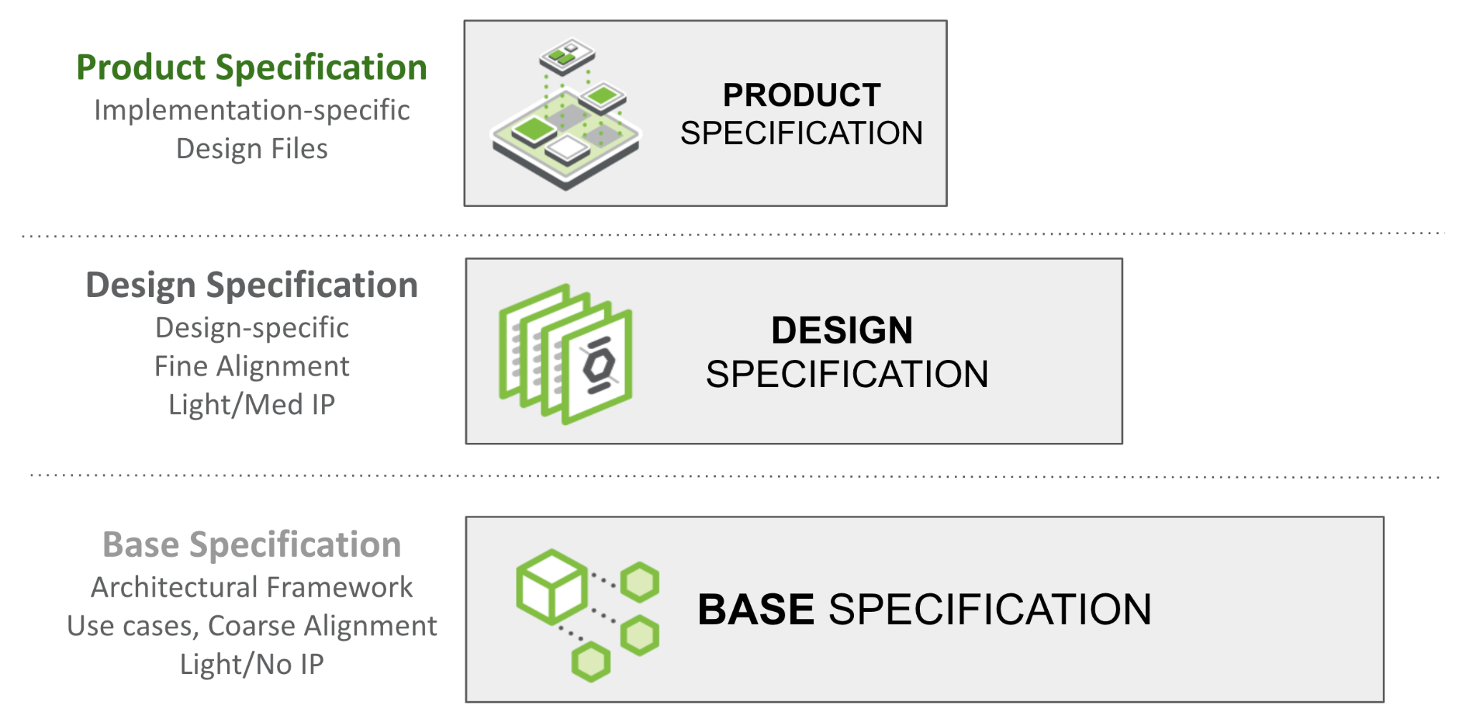

Figure 1: Specification Layers

## Usage

*The sections displayed within this document contain examples. Any contributions that do not have any section may delete it. For example if the contribution is for a ORv3 labeling system- not many of the example sections herein apply, therefore contributors may delete.*

## Base Specification Layer

*The Base Specification is an architectural framework for coarse alignment— a requirements description for flexible hardware and software modules/layers to interoperate. Market requirements drive Base Specifications. Without defining details of a specific design, the Base Specification may be light on IP content. This structure enables and simplifies the process for multiple parties (including potential competitors) to engage in this phase.*

*Please see the* [*presentation*](https://146a55aca6f00848c565-a7635525d40ac1c70300198708936b4e.ssl.cf1.rackcdn.com/images/4d14a1280e13c7dcf17123678eedc7e56053de96.pdf) *and* [*recording*](https://www.youtube.com/watch?v=IKqGFyE0V9E) *on the Modular Contribution Process from the OCP Global Summit 2022 for more information.*

*This layer as described, defines the technical details for one of the following types of specifications:*

* *Conceptual framework for an extensible technology platform/layer, representing technical community wide consensus and possibly used as a de-facto standard*
* *Requirements for a specific solution*
* *Extension/modification of an existing specification (state which existing spec is being modified)* 
  + *either a complete version update*
  + *a minor revision*

*Note: Any supplier seeking OCP recognition must be 100% compliant with the requirements/compliance statement listed in the Base requirements and subsequent design and product specifications as described.*

## Design Specification Layer

*The Design Specification captures customer requirements for finer alignment by building on the Base Specification (Spec). If a Base Specification provides general requirements and design goals, the Design Specifications has detail that further defines what specific role this contribution plays, and enough detailed design information such as high level board layouts etc that enables end users to begin the journey to realize this in the market. One or more parties may join to develop detailed design specs. Compared to the Base Specification, this effort typically contains significantly more detail such as future roadmaps and IP-related information. This group may have a multi-party NDA on their own (outside of the OCP umbrella) for the normal practice of developing products.*

*Design Specifications can be reused! I.e., if one contributor uses an indoor design specification, another team could reuse and make an outdoor specification. Having the same Base Specification for several Design Specifications will help increase the commonality of physical and logical interfaces to meet a set of common infrastructure hw/sw/fw requirements while allowing gen-to-gen variations or product differentiation.*

*This document defines the technical details for one of the following types of specifications:*

* *Design Specification for an intended physical <hardware product type>*
* *modification of an existing specification (state which existing spec is being modified)* 
  + *either a complete version update or*
  + *a minor revision update*
* *a specification with additional detail over the Base Specification for a <product type> with a target of a product (for example, a reference design) typically being available in 180 days of approval of this Spec. Note, this timeline might be extendable, depending on the approval from OCP Project Leadership for the project from within this specification is being developed, in cases, for example, feedback/updates required from the Base Specification from which this is derived.*

*\* Note: Few Base Specifications were submitted prior to the final approved template.*

## Product Specification Layer

*The Product Specification captures manufacturing requirements including all design and build files, building on the Design Specification. Typically even fewer companies will engage to create a single product specification, but the goal is to increase the total number of products that meet a Design Specification (derived from a Base Specification). The resulting Product Specification shall be contributed to OCP (via a Final Specification Agreement: FSA). A product typically goes through much effort for qualification and mass-production readiness beyond what specified in a typical design spec.*

*Product Specifications can be reused! I.e., assuming the base and design specifications allow, if one contributor creates a 110VAC design specification, another team could reuse and make an -48VDC product specification.*

*At Product(ization) Phase, even fewer companies may be involved to develop a specific final product for contribution to OCP. A Product may be submitted to OCP for “OCP Accepted™” or “OCP Inspired™” designation (with different levels of collateral such as a Design Package).*

*Please see the* [*presentation*](https://146a55aca6f00848c565-a7635525d40ac1c70300198708936b4e.ssl.cf1.rackcdn.com/images/4d14a1280e13c7dcf17123678eedc7e56053de96.pdf) *and* [*recording*](https://www.youtube.com/watch?v=IKqGFyE0V9E) *on the Modular Contribution Process from the OCP Global Summit 2022 for more information.*

*This document defines the technical details for one of the following types of specifications:*

* *Product Specification for an intended physical <hardware product type>*
* *modification of an existing product specification (state which existing spec is being modified)* 
  + *either a complete version update or*
  + *a minor revision update*
* *a detailed specification for a <product type> with a product typically being available in 120 days of approval of this Spec.*

*Note: Any supplier seeking OCP recognition, for example OCP Accepted, for a hardware product, must be using a product spec that is 100% compliant with the preceding Base requirements, Design specification and these Product Specifications as described.*

| DELETE THIS BLOCK BEFORE SUBMITTING |
| --- |
| INSTRUCTIONS FOR THE FOLLOWING SECTIONS:   * The following sections are required to document features and functions of the contributed system, subsystem, platform, card, component or other unit as appropriate- and are broken out into layers. * The layout of the sections has some boilerplate and random examples. These are illustrative only. Please rearrange, add, delete, and change as necessary to describe the contribution. * Be sure to complete only the incremental requirements for each subsequent layer. (ex: Assume Base Specification and include only changes in the Product Specifications, etc…) * Please use the OCP Terminology Guidelines for Inclusion and Openness. * No NDA (Non-disclosure Agreement) or confidential material is to be included in this document, including charts and included materials. This will be an OPEN document. |

# 

# Overview

Describe your contribution and the modularity of this spec within the framework of modular specification process (this might be the openness tenet too) Include the problems it addresses. Explain its utility within the Open Compute Project ecosystem.

# 

# Base Specifications

## Description

*Provide a high-level overview of the solution, including its key features, intended users, and any assumptions made during development.*

## Goals and Vision

*List the goals of the solution and any vision statements. This helps consumers of the specification understand the problem being addressed and how the solution fits into the broader context.*

## User Requirements/User Stories

*Include all end-user requirements and user stories that describe what the solution is supposed to do. Note that users may include other subsystems or platforms.*

## Solution Architecture

Provide a high-level view of the software’s elements, interfaces, and other significant components. Support this section with a diagram that visually represents the structure and relationships between various parts, illustrating how they interact and function together.

## Functional Requirements

*List the key functions the solution must perform, detailing how users interact with it and how the system responds. Include considerations for manageability, resilience, and availability.*

### Environmental Regulatory Compliance and Requirements

*Please describe any environmental regulations or requirements for any platform boards and full system, if applicable..*

## Non-Functional Requirements

*Describe qualities such as performance, usability, security, and maintainability that the software must exhibit.*

## Features

*Break down the solution’s specific features, explaining the purpose and functionality of each one.*

# Physical Requirements

*Please describe the physical requirements for your contribution. This may be the limitations of the physical envelope.*

*If this specification defines a chassis type system, be sure to include the description of the chassis and associated modules, midplane, backplanes etc….*

*Note to author of this specification: This section can include the following but is not limited to the below items:*

* *Block Diagrams*
* *Form Factor Requirements*
* *Figures & Illustrations*

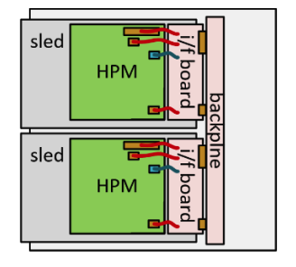

Sample Physical Diagram

# Mechanical

*Please describe any key mechanical requirements of your contribution.*

## Rack Compatibility

*Please describe if your contribution will be used in a rack installation. If the contribution is rack mountable, the specification must be compliant with one of the following OCP approved rack types: OpenRack (V3.X and beyond), EIA-310, OpenEdge.*

## General Requirements

*Note to author of this specification: This section can include the following but is not limited to the below items:*

* *Chassis*
* *Single sled/double sled*

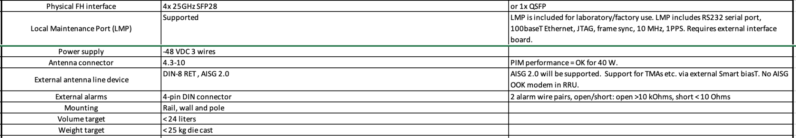

Dual-Band RRU Mechanical Requirements

# Electrical Requirements

*Please describe general electrical power requirements. Example: Power Input envelope +48VDC, 110VAC, peak/average power, etc…*

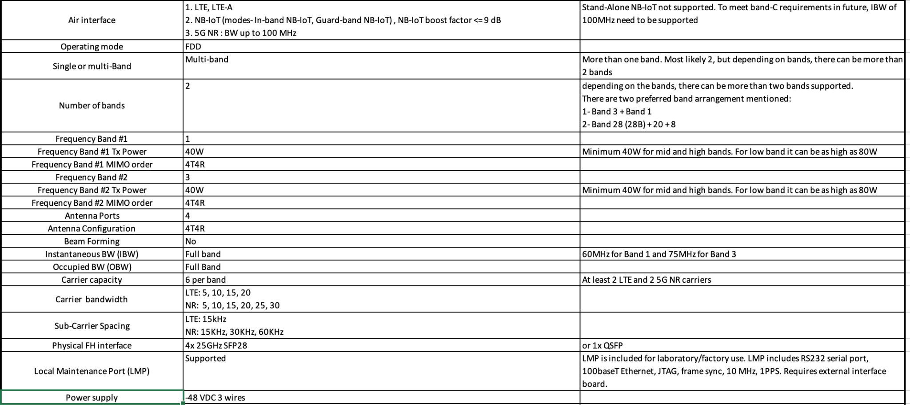

Dual-Band RRU Electrical Requirements

# Thermal Design Requirements

*Please describe the thermal design requirements for your contribution and any CFD and/or thermal models etc...*

*Note to author of this specification: Examples include:*

* *Cooling Media*
* *Flow Management*
* *Fan Controls*

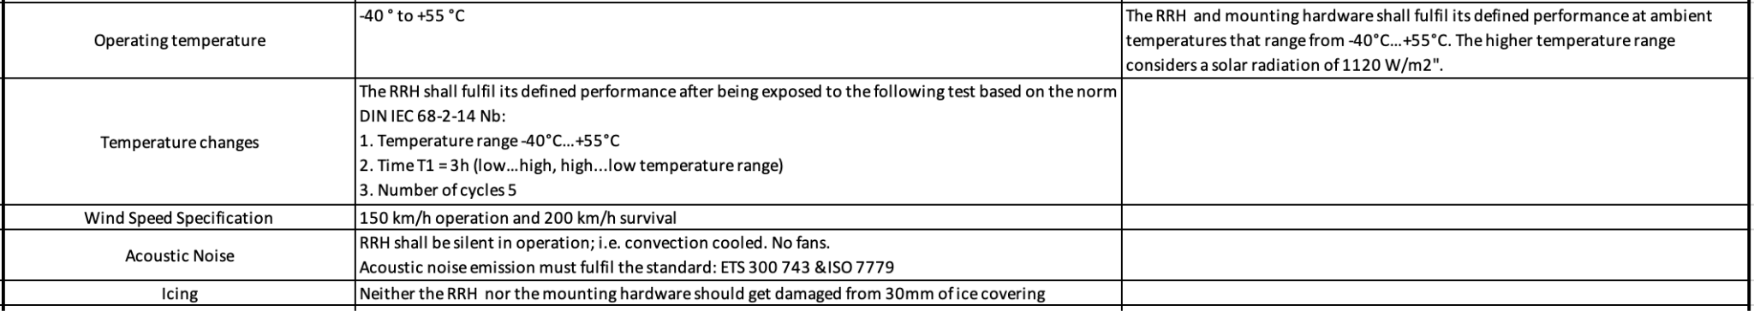

Example: Dual-Band RRU Thermal Requirements

# Onboard Power

*Please describe the architecture of the power systems and requirements in your contribution.*

*Note to author of this specification: This section can include the following but is not limited to the below items:*

* *Voltage Regulation*
* *Power Management*
* *Input voltages*
* *Hot swap controller circuit*
* *Hard drive power*
* *Power Tree*
* *Power Policy*
* *Power Budget*
* *Platform Budget*
* *Capacitive Load*

**

Example: Dual-Band RRU Power Supply Requirements

## Interface Requirements

*Explain how the solution will interact with other systems or users, including hardware interfaces, software APIs, or communication protocols.*

*Please describe the I/O System of the contribution, be sure to delineate the control and data planes. Block diagrams here.*

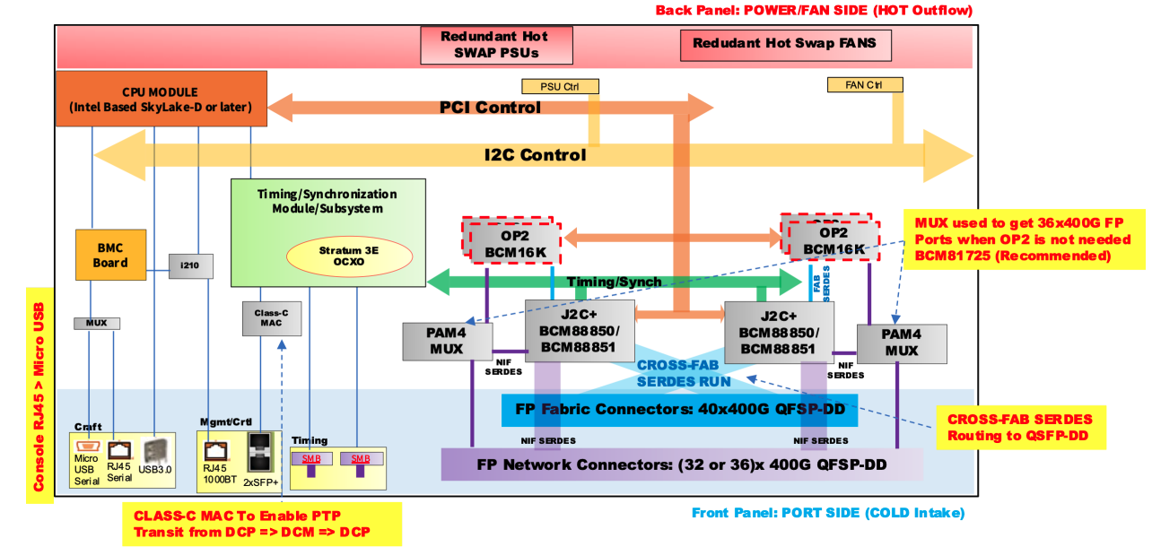

Sample Block Diagram Showing Interfaces

## Signal List

*Note to author of this specification: Examples only*

* *Power and Ground*
* *Synchronization/Clocks*
* *PCIe*
* *i2C/i3C*
* *GPIO*
* *USB 3.0*

## Rear Side Power, I/O, Expansion Board and Midplane Subsystems

*Please describe any modular design implementation requirements of the contribution.*

*Note to author of this specification: This section can include the following but is not limited to the below items:*

* *​​Overview of Footprint and Population Options*
* *Rear Side Connectivity*
* *Midplane*
* *Expansion*
* *Fixed, redundant, modular, pluggable, adapter?*
* *Power, Grounding etc…*

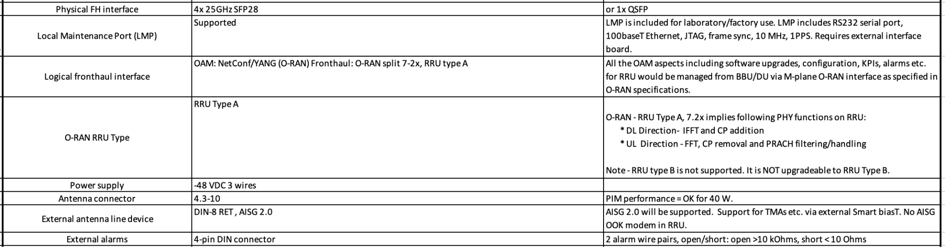

Example: Dual-Band RRU External Interface Requirements

## Performance Requirements

*Set expectations for the system’s speed and efficiency, including resource consumption targets and scalability considerations.*

## Security Requirements

*Detail the measures needed to keep the solution and end users secure from errors, cyber-attacks, or data breaches. Briefly describe the security functionalities that your specification requires and recommends. Include a “required by” date for any recommendations.*

*Note to author of this specification: This section* ***can*** *include the following but is not limited to the below items:*

* *For cryptography, key derivation, key agreement, and hashing, identify*

*o Required algorithms, modes, strengths, and usage*

*o Required compliance with national or international standards*

*o Acceptable sources of entropy*

*o Acceptable certifications of algorithm implementations*

*o Recommended certifications of cryptographic modules*

*o Recommended safeguards against cryptanalysis by quantum computers*

* *Required flow of Secure Boot starting from hardware root(s) of trust*
* *Required measurements from hardware reset through firmware*
* *Required attestation protocols*
* *Acceptable environments and processes for provisioning keys and device secrets*
* *Acceptable processes for identifying CVEs and distributing field updates to address them*
* *Acceptable Secure Boot and Attestation key lifecycle management (from generation through*
* *revocation)*
* *Recommended standards for software bills of materials*
* *Recommended firmware recovery mechanisms*

*\*Required = Required now*

*Acceptable = Required now and chosen from a list of acceptable alternatives*

*Note: Omit any items that do not apply and add any that are missing. Remember, the more detailed this specification is, the less flexibility is allowed during the design and product specification phases.*

# Hardware Management

*Please document the hardware management implementation of your contribution. Include Firmware (BIOS) optional Board Management Controller (BMC), Data Center Secure Control Modules (DC-SCM), etc.*

*Note to author of this specification: This section* ***should*** *include the following below items:*

* *Statement on whether the contribution supports out-of-band manageability.*
* *Statement on the modularity of the manageability architecture. (i.e. is an OCP management module used?)*

*Note to author of this specification: This section* ***can*** *include the following but is not limited to the below items:*

* *Architecture of out-of-band management*
  + *Dedicated or shared NIC*
  + *In which power state is the OOB management enabled*
* *A list of on-platform manageability interfaces:*
  + *Connections: I2C/I3C, SMBus, RMII,*
  + *Transport Protocol: MCTP, IPMI (KCS, BT, etc)*
  + *Commands constructs: PLDM …, IPMI, SPDM, CPER*
  + *A list of components whose firmware which can updated programmatically*
    - *Which support failover/rollback mechanisms*
  + *A list of diagnostic or management LEDs supported*
  + *A list of minimum telemetry/sensors*
  + *A list of minimum controls*
  + *Whether conformance to OCP Profiles has been tested*
  + *For Arm-based Servers, whether conformance to Arm Server Base Manageability Requirements Specification has been followed. If so, please also indicate the conformance level (e.g., M2)*

## Constraints

*List any limitations the solution must account for, such as hardware constraints, legal regulations, or specific tools that the OCP community must consider.*

*Document any hardware management implementations either dependent on or to your contribution, including firmware (BIOS), optional Board Management Controller (BMC), Data Center Secure Control Modules (DC-SCM), etc.*

## Test and Validation Requirements

# *Provide the concepts for testing and validation of this solution.*

## External Software/Firmware Support (*Strongly* recommended)

*Identify any external software or firmware required to support the contribution, including notional architecture and necessary features. Provide information about the OCP GitHub repository where the project is hosted.*

# Compliance

| DELETE THIS BLOCK BEFORE SUBMITTING |
| --- |
| INSTRUCTIONS FOR THE FOLLOWING SECTIONS:   * This mandatory section is the checklist for the consumers of the specification to adhere to in order for them to declare it complies to the requirements. This applies to any implementations (OCP Marketplace or not) that declare compliance with this specification. * For a Base specification, this declaration could refer to other Base specifications but would need to introduce significant differences and not be something that could merely be overridden in higher level specifications to avoid confusion or lacking for purpose. * For a Base Specification only, this section could be pretty sparse. If someone can build something from your Base Specification, then consider what minimum requirements make it comply and leave the specifics to subsequent specifications. * It is also possible to make the requirement full compliance with all of the items in this specification. This is not the intent of the Base Specification. |

*(Example Compliance Table Follows)*

| ***ITEM*** | ***REQUIREMENT*** | ***REFERENCE*** | ***MANDATORY*** |
| --- | --- | --- | --- |
| *1* | *If scalable HPM depth >372.5mm (from origin), additional Zone 2 KOZs shall be*  *implemented.* | *10.3.2 (multiple items)* | *Y* |
| *2* | *Optional: The device shall only clear the Timestamp Origin field to 000b in the Timestamp (Feature*  *Identifier 0Eh) on a main power cycle or NVM Subsystem Reset (e.g., NSSR). The device*  *shall not clear the Timestamp Origin field on a power cycle of only AUX power.* | *NVMe-OPT-4* | *N* |
| *3* | *Any supplier seeking OCP recognition for a hardware product based on this specification*  *shall be 100% compliant* | *4* | *Y* |

*All Products seeking OCP Accepted™ Product Recognition shall have source code and binary*

*blobs submitted for BMC, if applicable.*

*The BMC management source code shall be uploaded at:*

[*https://github.com/opencomputeproject/Hardware-Management/[vendor_name]/[product_name*](https://github.com/opencomputeproject/Hardware-Management/%5Bvendor_name%5D/%5Bproduct_name)*]*

# Arm SystemReady (only for Arm-based Systems) Requirement

Please document if this contribution is designed to meet requirements for the Arm SystemReady certificate.

*Note to author of this specification: This section* ***can*** *include the following but is not limited to the below items:*

* For Server Sleds, Open Edge Sleds and Monolithic Servers, the certification of either SystemReady SR or LS certification is required.
* For Storage and Networking, the certification of SystemReady SR, LS, ES, or IR is recommended.
* For Systems that are SystemReady SR, ES or IR certified, SystemReady Security Interface Extension (SIE) certification is recommended.

More details on Arm SystemReady can be found at https://www.arm.com/architecture/system-architectures/systemready-certification-program.

## Repository Location

*It is highly recommended that OCP projects participate in a collaborative development process. OCP provides GitHub resources—with access control if needed—for this purpose. Please request a repository for your contribution from your project leads.*

*Include the OCP GitHub repository information here.*

## Prescribed Materials

*List any prescribed materials included in your contribution, such as specific components that are referenced but not contributed.*

*This section may include, but is not limited to:*

* *Disallowed components.*
* *Specifically required components with no substitution allowed.*

## References (recommended)

[1] “Title”, publication year, OCP specification, version, link to publication if available.

[2] “Title”, publication year, publication journal/conference/standard, volume, pages, link to publication if available.

# 

# Design Specifications

Reminder to authors, this section refines the previous section, so it’s unnecessary to strictly repeat the previous sections, only add what modifies and refines the previous. This section is for the Design Specifications. If a Base Specification provides general requirements and design goals, the Design Specifications has detail that further defines what specific role this contribution plays, and enough detailed design information such as high level board layouts, enumerations, etc that enables end users to utilize this part of the specifications to begin the journey to realize this design.

## Description

*Provide a high-level overview of the solution, including its key features, intended users, and any assumptions made during development.*

## User Requirements/User Stories

*Include all end-user requirements and user stories that describe what the solution is supposed to do. Note that users may include other subsystems or platforms.*

## Solution Architecture

Provide a detailed view of the solution’s elements, interfaces, and other significant components. Support this section with a diagram that visually represents the structure and relationships between various parts, illustrating how they interact and function together.

## Supported Functions

*List the key functions the solution must perform, detailing how users interact with it and how the system responds. Include considerations for manageability, resilience, and availability.*

### Environmental Regulatory Compliance and Design

*Please describe any environmental regulations or requirements for any platform boards and full system, if applicable..*

*Note to author of this specification: This section can include the following but is not limited to the below items:*

* *UL/CE/NRTL/FCC/IEC/EN/etc Requirements*
* *RoHS/WEE directives, REACH regulations*
* *NEBS compliance requirements*
* *Operating temperature range*
* *Storage temperature range*
* *Transportation temperature range*
* *Shock and Vibration requirements*
* *Operating Altitude*

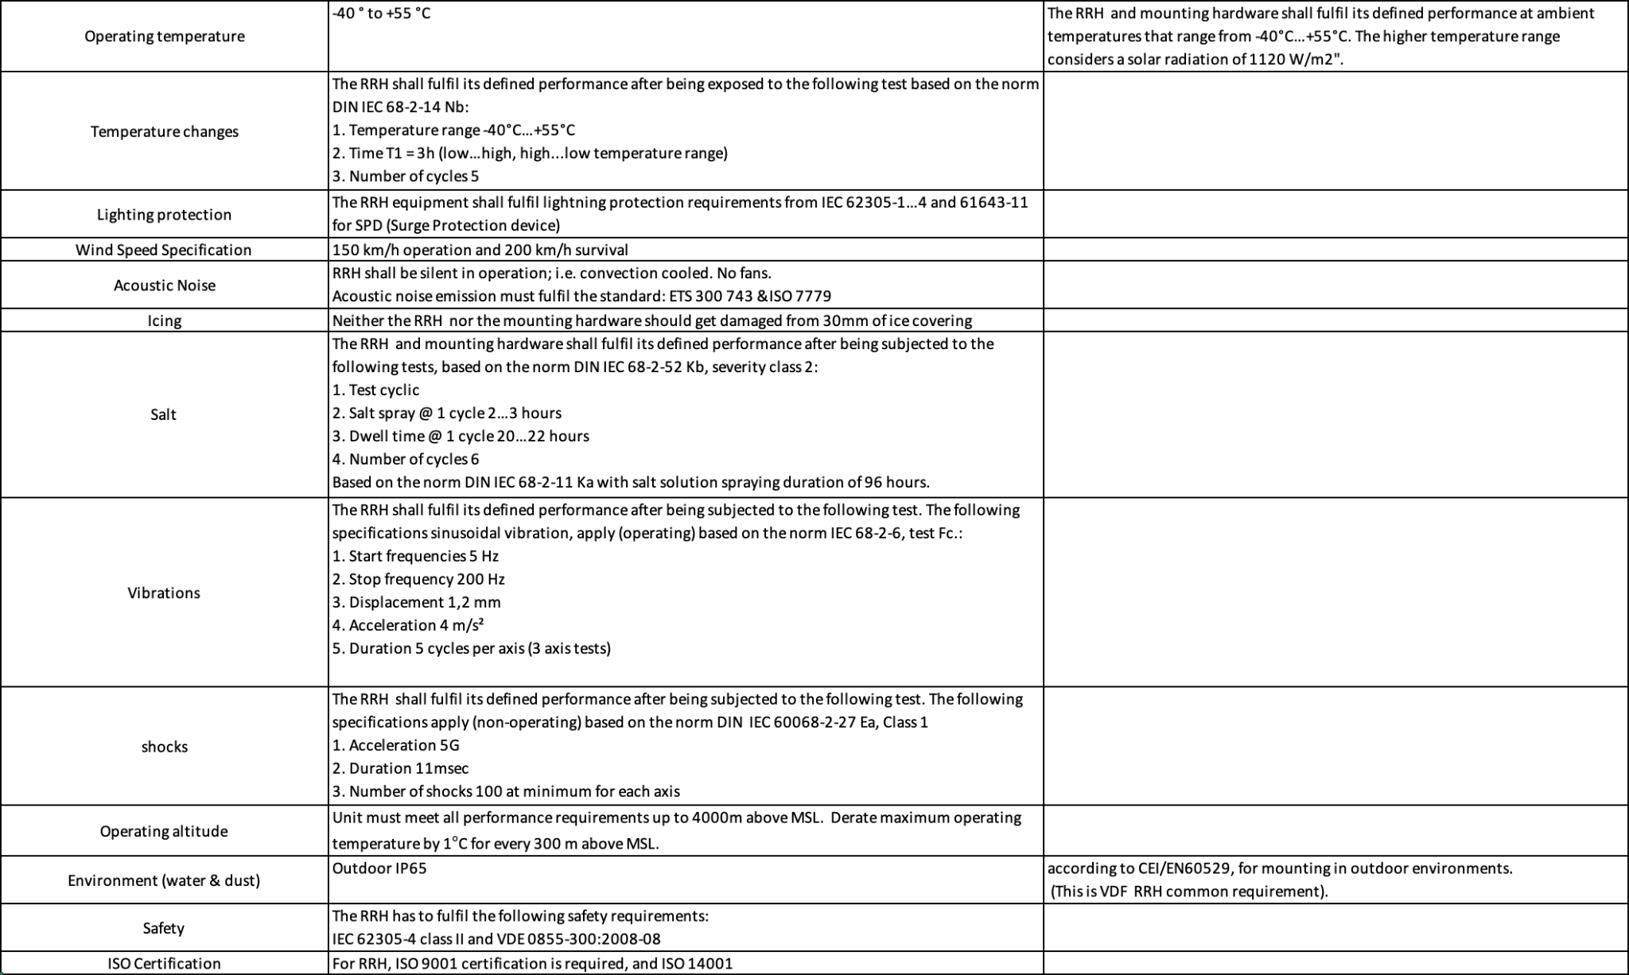

Example Outdoor Equipment Environmental Requirements

## Non-Functional Requirements

*Describe qualities such as performance, usability, security, and maintainability that the software must exhibit.*

## Features

*Break down the solution’s specific features, explaining the purpose and functionality of each one.*

## Physical Design

*Please describe the physical requirements for your contribution. This may be the limitations of the physical envelope.*

*If this specification defines a chassis type system, be sure to include the description of the chassis and associated modules, midplane, backplanes etc….*

*Note to author of this specification: This section can include the following but is not limited to the below items:*

* *Block Diagrams*
* *Form Factor Requirements*
* *Figures & Illustrations*

**

Sample Physical Diagram

## Mechanical Design

*Please describe any key mechanical requirements of your contribution.*

## Rack Compatibility

*Please describe if your contribution will be used in a rack installation. If the contribution is rack mountable, the specification must be compliant with one of the following OCP approved rack types: OpenRack (V3.X and beyond), EIA-310, OpenEdge.*

## General Requirements

*Note to author of this specification: This section can include the following but is not limited to the below items:*

* *Chassis*
* *Single sled/double sled*

**

Dual-Band RRU Mechanical Requirements

## Electrical Requirements

*Please describe general electrical power requirements. Example: Power Input envelope +48VDC, 110VAC, peak/average power, etc…*

**

Dual-Band RRU Electrical Requirements

## Thermal Design Requirements

*Please describe the thermal design requirements for your contribution and any CFD and/or thermal models etc...*

*Note to author of this specification: Examples include:*

* *Cooling Media*
* *Flow Management*
* *Fan Controls*

**

Example: Dual-Band RRU Thermal Requirements

## Onboard Power

*Please describe the architecture of the power systems and requirements in your contribution.*

*Note to author of this specification: This section can include the following but is not limited to the below items:*

* *Voltage Regulation*
* *Power Management*
* *Input voltages*
* *Hot swap controller circuit*
* *Hard drive power*
* *Power Tree*
* *Power Policy*
* *Power Budget*
* *Platform Budget*
* *Capacitive Load*

**

Example: Dual-Band RRU Power Supply Requirements

## Interfaces

*Explain how the solution will interact with other systems or users, including hardware interfaces, software APIs, or communication protocols.*

*Please describe the I/O System of the contribution, be sure to delineate the control and data planes. Block diagrams here.*

**

Sample Block Diagram Showing Interfaces

## Signal List

*Note to author of this specification: Examples only*

* *Power and Ground*
* *Synchronization/Clocks*
* *PCIe*
* *i2C/i3C*
* *GPIO*
* *USB 3.0*

## Rear Side Power, I/O, Expansion Board and Midplane Subsystems

*Please describe any modular design implementation requirements of the contribution.*

*Note to author of this specification: This section can include the following but is not limited to the below items:*

* *​​Overview of Footprint and Population Options*
* *Rear Side Connectivity*
* *Midplane*
* *Expansion*
* *Fixed, redundant, modular, pluggable, adapter?*
* *Power, Grounding etc…*

**

Example: Dual-Band RRU External Interface Requirements

## Performance

*Set expectations for the system’s speed and efficiency, including resource consumption targets and scalability considerations.*

## Security

*Detail the measures needed to keep the solution and end users secure from errors, cyber-attacks, or data breaches. Briefly describe the security functionalities that your specification requires and recommends. Include a “required by” date for any recommendations.*

*Note to author of this specification: This section* ***can*** *include the following but is not limited to the below items:*

* *For cryptography, key derivation, key agreement, and hashing, identify*

*o Required algorithms, modes, strengths, and usage*

*o Required compliance with national or international standards*

*o Acceptable sources of entropy*

*o Acceptable certifications of algorithm implementations*

*o Recommended certifications of cryptographic modules*

*o Recommended safeguards against cryptanalysis by quantum computers*

* *Required flow of Secure Boot starting from hardware root(s) of trust*
* *Required measurements from hardware reset through firmware*
* *Required attestation protocols*
* *Acceptable environments and processes for provisioning keys and device secrets*
* *Acceptable processes for identifying CVEs and distributing field updates to address them*
* *Acceptable Secure Boot and Attestation key lifecycle management (from generation through*
* *revocation)*
* *Recommended standards for software bills of materials*
* *Recommended firmware recovery mechanisms*

*\*Required = Required now*

*Acceptable = Required now and chosen from a list of acceptable alternatives*

*Note: Omit any items that do not apply and add any that are missing. Remember, the more detailed this specification is, the less flexibility is allowed during the design and product specification phases.*

# Hardware Management

*Please document the hardware management implementation of your contribution. Include Firmware (BIOS) optional Board Management Controller (BMC), Data Center Secure Control Modules (DC-SCM), etc.*

*Note to author of this specification: This section* ***should*** *include the following below items:*

* *Statement on whether the contribution supports out-of-band manageability.*
* *Statement on the modularity of the manageability architecture. (i.e. is an OCP management module used?)*

*Note to author of this specification: This section* ***can*** *include the following but is not limited to the below items:*

* *Architecture of out-of-band management*
  + *Dedicated or shared NIC*
  + *In which power state is the OOB management enabled*
* *A list of on-platform manageability interfaces:*
  + *Connections: I2C/I3C, SMBus, RMII,*
  + *Transport Protocol: MCTP, IPMI (KCS, BT, etc)*
  + *Commands constructs: PLDM …, IPMI, SPDM, CPER*
  + *A list of components whose firmware which can updated programmatically*
    - *Which support failover/rollback mechanisms*
  + *A list of diagnostic or management LEDs supported*
  + *A list of minimum telemetry/sensors*
  + *A list of minimum controls*
  + *Whether conformance to OCP Profiles has been tested*
  + *For Arm-based Servers, whether conformance to Arm Server Base Manageability Requirements Specification has been followed. If so, please also indicate the conformance level (e.g., M2)*

## Constraints

*List any limitations the solution must account for, such as hardware constraints, legal regulations, or specific tools that the OCP community must consider.*

*Document any hardware management implementations either dependent on or to your contribution, including firmware (BIOS), optional Board Management Controller (BMC), Data Center Secure Control Modules (DC-SCM), etc.*

## Test and Validation

# *Provide the concepts for testing and validation of this solution.*

## External Software/Firmware Support (*Strongly* recommended)

*Identify any external software or firmware required to support the contribution, including notional architecture and necessary features. Provide information about the OCP GitHub repository where the project is hosted.*

## Compliance

| DELETE THIS BLOCK BEFORE SUBMITTING |
| --- |
| INSTRUCTIONS FOR THE FOLLOWING SECTIONS:   * This mandatory section is the checklist for the consumers of the specification to adhere to in order for them to declare it complies to the requirements. This applies to any implementations (OCP Marketplace or not) that declare compliance with this specification. * For a Design specification, this declaration should refer to the base specifications for completeness, can include blanket statements if complies, and absolutely needs to list exceptions. |

*(Example Compliance Table Follows)*

| ***ITEM*** | ***REQUIREMENT*** | ***REFERENCE*** | ***MANDATORY*** |
| --- | --- | --- | --- |
| *1* | *If scalable HPM depth >372.5mm (from origin), additional Zone 2 KOZs shall be*  *implemented.* | *10.3.2 (multiple items)* | *Y* |
| *2* | *Optional: The device shall only clear the Timestamp Origin field to 000b in the Timestamp (Feature*  *Identifier 0Eh) on a main power cycle or NVM Subsystem Reset (e.g., NSSR). The device*  *shall not clear the Timestamp Origin field on a power cycle of only AUX power.* | *NVMe-OPT-4* | *N* |
| *3* | *Any supplier seeking OCP recognition for a hardware product based on this specification*  *shall be 100% compliant* | *4* | *Y* |

*All Products seeking OCP Accepted™ Product Recognition shall have source code and binary*

*blobs submitted for BMC, if applicable.*

*The BMC management source code shall be uploaded at:*

[*https://github.com/opencomputeproject/Hardware-Management/[vendor_name]/[product_name*](https://github.com/opencomputeproject/Hardware-Management/%5Bvendor_name%5D/%5Bproduct_name)*]*

## Arm SystemReady (only for Arm-based Systems) Requirement

Please document if this contribution is designed to meet requirements for the Arm SystemReady certificate.

*Note to author of this specification: This section* ***can*** *include the following but is not limited to the below items:*

* For Server Sleds, Open Edge Sleds and Monolithic Servers, the certification of either SystemReady SR or LS certification is required.
* For Storage and Networking, the certification of SystemReady SR, LS, ES, or IR is recommended.
* For Systems that are SystemReady SR, ES or IR certified, SystemReady Security Interface Extension (SIE) certification is recommended.

More details on Arm SystemReady can be found at https://www.arm.com/architecture/system-architectures/systemready-certification-program.

## Repository Location

*It is highly recommended that OCP projects participate in a collaborative development process. OCP provides GitHub resources—with access control if needed—for this purpose. Please request a repository for your contribution from your project leads.*

*Include the OCP GitHub repository information here.*

## Prescribed Materials

*List any prescribed materials included in your contribution, such as specific components that are referenced but not contributed.*

*This section may include, but is not limited to:*

* *Disallowed components.*
* *Specifically required components with no substitution allowed.*

## References (recommended)

[1] “Title”, publication year, OCP specification, version, link to publication if available.

[2] “Title”, publication year, publication journal/conference/standard, volume, pages, link to publication if available.

# Product Specifications

Reminder to authors, this section refines the previous sections, so it’s unnecessary to strictly repeat the previous sections, only add what modifies the previous. This section, the Product Specifications, requires further detail such as but not limited to bills of materials with component part numbers, supporting gerber/design, software, tools and any other files required to be able to produce the contribution.

## Description

*Provide a high-level overview of the solution, including its key features, intended users, and any assumptions made during development.*

## User Requirements/User Stories

*Include all end-user requirements and user stories that describe what the solution is supposed to do. Note that users may include other subsystems or platforms.*

## Solution Architecture

Provide a detailed view of the solution’s elements, interfaces, and other significant components. Support this section with a diagram that visually represents the structure and relationships between various parts, illustrating how they interact and function together.

## Supported Functions

*List the key functions the solution must perform, detailing how users interact with it and how the system responds. Include considerations for manageability, resilience, and availability.*

### Environmental Regulatory Compliance and Design

*Please describe any environmental regulations or requirements for any platform boards and full system, if applicable..*

*Note to author of this specification: This section can include the following but is not limited to the below items:*

* *UL/CE/NRTL/FCC/IEC/EN/etc Requirements*
* *RoHS/WEE directives, REACH regulations*
* *NEBS compliance requirements*
* *Operating temperature range*
* *Storage temperature range*
* *Transportation temperature range*
* *Shock and Vibration requirements*
* *Operating Altitude*

**

Example Outdoor Equipment Environmental Requirements

## Non-Functional Requirements

*Describe qualities such as performance, usability, security, and maintainability that the software must exhibit.*

## Features

*Break down the solution’s specific features, explaining the purpose and functionality of each one.*

## Physical Design

*Please describe the physical requirements for your contribution. This may be the limitations of the physical envelope.*

*If this specification defines a chassis type system, be sure to include the description of the chassis and associated modules, midplane, backplanes etc….*

*Note to author of this specification: This section can include the following but is not limited to the below items:*

* *Block Diagrams*
* *Form Factor Requirements*
* *Figures & Illustrations*

**

Sample Physical Diagram

## Mechanical Design

*Please describe any key mechanical requirements of your contribution.*

## Rack Compatibility

*Please describe if your contribution will be used in a rack installation. If the contribution is rack mountable, the specification must be compliant with one of the following OCP approved rack types: OpenRack (V3.X and beyond), EIA-310, OpenEdge.*

## General Requirements

*Note to author of this specification: This section can include the following but is not limited to the below items:*

* *Chassis*
* *Single sled/double sled*

**

Dual-Band RRU Mechanical Requirements

## Electrical Requirements

*Please describe general electrical power requirements. Example: Power Input envelope +48VDC, 110VAC, peak/average power, etc…*

**

Dual-Band RRU Electrical Requirements

## Thermal Design Requirements

*Please describe the thermal design requirements for your contribution and any CFD and/or thermal models etc...*

*Note to author of this specification: Examples include:*

* *Cooling Media*
* *Flow Management*
* *Fan Controls*

**

Example: Dual-Band RRU Thermal Requirements

## Onboard Power

*Please describe the architecture of the power systems and requirements in your contribution.*

*Note to author of this specification: This section can include the following but is not limited to the below items:*

* *Voltage Regulation*
* *Power Management*
* *Input voltages*
* *Hot swap controller circuit*
* *Hard drive power*
* *Power Tree*
* *Power Policy*
* *Power Budget*
* *Platform Budget*
* *Capacitive Load*

**

Example: Dual-Band RRU Power Supply Requirements

## Interfaces

*Explain how the solution will interact with other systems or users, including hardware interfaces, software APIs, or communication protocols.*

*Please describe the I/O System of the contribution, be sure to delineate the control and data planes. Block diagrams here.*

**

Sample Block Diagram Showing Interfaces

## Signal List

*Note to author of this specification: Examples only*

* *Power and Ground*
* *Synchronization/Clocks*
* *PCIe*
* *i2C/i3C*
* *GPIO*
* *USB 3.0*

## Rear Side Power, I/O, Expansion Board and Midplane Subsystems

*Please describe any modular design implementation requirements of the contribution.*

*Note to author of this specification: This section can include the following but is not limited to the below items:*

* *​​Overview of Footprint and Population Options*
* *Rear Side Connectivity*
* *Midplane*
* *Expansion*
* *Fixed, redundant, modular, pluggable, adapter?*
* *Power, Grounding etc…*

**

Example: Dual-Band RRU External Interface Requirements

## Performance

*Set expectations for the system’s speed and efficiency, including resource consumption targets and scalability considerations.*

## Security

*Detail the measures needed to keep the solution and end users secure from errors, cyber-attacks, or data breaches. Briefly describe the security functionalities that your specification requires and recommends. Include a “required by” date for any recommendations.*

*Note to author of this specification: This section* ***can*** *include the following but is not limited to the below items:*

* *For cryptography, key derivation, key agreement, and hashing, identify*

*o Required algorithms, modes, strengths, and usage*

*o Required compliance with national or international standards*

*o Acceptable sources of entropy*

*o Acceptable certifications of algorithm implementations*

*o Recommended certifications of cryptographic modules*

*o Recommended safeguards against cryptanalysis by quantum computers*

* *Required flow of Secure Boot starting from hardware root(s) of trust*
* *Required measurements from hardware reset through firmware*
* *Required attestation protocols*
* *Acceptable environments and processes for provisioning keys and device secrets*
* *Acceptable processes for identifying CVEs and distributing field updates to address them*
* *Acceptable Secure Boot and Attestation key lifecycle management (from generation through*
* *revocation)*
* *Recommended standards for software bills of materials*
* *Recommended firmware recovery mechanisms*

*\*Required = Required now*

*Acceptable = Required now and chosen from a list of acceptable alternatives*

*Note: Omit any items that do not apply and add any that are missing. Remember, the more detailed this specification is, the less flexibility is allowed during the design and product specification phases.*

# Hardware Management

*Please document the hardware management implementation of your contribution. Include Firmware (BIOS) optional Board Management Controller (BMC), Data Center Secure Control Modules (DC-SCM), etc.*

*Note to author of this specification: This section* ***should*** *include the following below items:*

* *Statement on whether the contribution supports out-of-band manageability.*
* *Statement on the modularity of the manageability architecture. (i.e. is an OCP management module used?)*

*Note to author of this specification: This section* ***can*** *include the following but is not limited to the below items:*

* *Architecture of out-of-band management*
  + *Dedicated or shared NIC*
  + *In which power state is the OOB management enabled*
* *A list of on-platform manageability interfaces:*
  + *Connections: I2C/I3C, SMBus, RMII,*
  + *Transport Protocol: MCTP, IPMI (KCS, BT, etc)*
  + *Commands constructs: PLDM …, IPMI, SPDM, CPER*
  + *A list of components whose firmware which can updated programmatically*
    - *Which support failover/rollback mechanisms*
  + *A list of diagnostic or management LEDs supported*
  + *A list of minimum telemetry/sensors*
  + *A list of minimum controls*
  + *Whether conformance to OCP Profiles has been tested*
  + *For Arm-based Servers, whether conformance to Arm Server Base Manageability Requirements Specification has been followed. If so, please also indicate the conformance level (e.g., M2)*

## Constraints

*List any limitations the solution must account for, such as hardware constraints, legal regulations, or specific tools that the OCP community must consider.*

*Document any hardware management implementations either dependent on or to your contribution, including firmware (BIOS), optional Board Management Controller (BMC), Data Center Secure Control Modules (DC-SCM), etc.*

## Test and Validation

# *Provide the concepts for testing and validation of this solution.*

## External Software/Firmware Support (*Strongly* recommended)

*Identify any external software or firmware required to support the contribution, including notional architecture and necessary features. Provide information about the OCP GitHub repository where the project is hosted.*

## Compliance

| DELETE THIS BLOCK BEFORE SUBMITTING |
| --- |
| INSTRUCTIONS FOR THE FOLLOWING SECTIONS:   * This mandatory section is the checklist for the consumers of the specification to adhere to in order for them to declare it complies to the requirements. This applies to any implementations (OCP Marketplace or not) that declare compliance with this specification. * For a Product specification, this declaration should refer to the OCP Base and Design specifications and this can be done with aggregated statements like “complies to the design specification requirements” etc… but also lists the unique properties which this spec contains. |

*(Example Compliance Table Follows)*

| ***ITEM*** | ***REQUIREMENT*** | ***REFERENCE*** | ***MANDATORY*** |
| --- | --- | --- | --- |
| *1* | *If scalable HPM depth >372.5mm (from origin), additional Zone 2 KOZs shall be*  *implemented.* | *10.3.2 (multiple items)* | *Y* |
| *2* | *Optional: The device shall only clear the Timestamp Origin field to 000b in the Timestamp (Feature*  *Identifier 0Eh) on a main power cycle or NVM Subsystem Reset (e.g., NSSR). The device*  *shall not clear the Timestamp Origin field on a power cycle of only AUX power.* | *NVMe-OPT-4* | *N* |
| *3* | *Any supplier seeking OCP recognition for a hardware product based on this specification*  *shall be 100% compliant* | *4* | *Y* |

*All Products seeking OCP Accepted™ Product Recognition shall have source code and binary*

*blobs submitted for BMC, if applicable.*

*The BMC management source code shall be uploaded at:*

[*https://github.com/opencomputeproject/Hardware-Management/[vendor_name]/[product_name*](https://github.com/opencomputeproject/Hardware-Management/%5Bvendor_name%5D/%5Bproduct_name)*]*

## Arm SystemReady (only for Arm-based Systems) Requirement

Please document if this contribution is designed to meet requirements for the Arm SystemReady certificate.

*Note to author of this specification: This section* ***can*** *include the following but is not limited to the below items:*

* For Server Sleds, Open Edge Sleds and Monolithic Servers, the certification of either SystemReady SR or LS certification is required.
* For Storage and Networking, the certification of SystemReady SR, LS, ES, or IR is recommended.
* For Systems that are SystemReady SR, ES or IR certified, SystemReady Security Interface Extension (SIE) certification is recommended.

More details on Arm SystemReady can be found at https://www.arm.com/architecture/system-architectures/systemready-certification-program.

## Repository Location

*It is highly recommended that OCP projects participate in a collaborative development process. OCP provides GitHub resources—with access control if needed—for this purpose. Please request a repository for your contribution from your project leads.*

*Include the OCP GitHub repository information here.*

## Prescribed Materials

*List any prescribed materials included in your contribution, such as specific components that are referenced but not contributed.*

*This section may include, but is not limited to:*

* *Disallowed components.*
* *Specifically required components with no substitution allowed.*

## References (recommended)

[1] “Title”, publication year, OCP specification, version, link to publication if available.

[2] “Title”, publication year, publication journal/conference/standard, volume, pages, link to publication if available.

## 

# Appendix A - Checklist for Steering Committee (SC) approval of this Specification (to be completed by contributor(s) of this Spec)

Complete all the checklist items in the table with links to the section where it is described in this spec or an external document .

| **Item** | **Status or Details** | **Link to detailed explanation** |
| --- | --- | --- |
| Is this contribution entered into the OCP Contribution Portal? | Yes or No | If no, please state the reason. |
| Was it approved in the OCP Contribution Portal? | Yes or No | If no, please state the reason. |
| Is there a Supplier(s) that is building a product based on this Spec? (Supplier must be an OCP Solution Provider) | Yes or No | List Supplier Name(s) |
| Will Supplier(s) have the product available for GENERAL AVAILABILITY within 120 days? | Yes or No | If more time is required, please state the timeline and reason for extension request.  Please have each Supplier fill out Appendix B. |

# 

# Appendix B-__ <supplier name> - OCP Supplier Information and Hardware Product Recognition Checklist

(to be provided by each supplier seeking OCP recognition for a Hardware Product based on this specification)

Company:

Contact Info:

Product Name:

Product SKU#:

Link to Product Landing Page:

The following is needed for OCP hardware product recognition:

**For OCP Inspired™**

* All Suppliers must be an OCP Member. All corporate membership levels are eligible.
* Declare product is 100% compliant with specification
* Complete the [OCP Inspired™ Product Recognition Checklist](https://docs.google.com/spreadsheets/d/1p7g_bPWzgXDDTkxbOEOkLrbvfKmqVWspKOi7J20yJcE/copy?resourcekey=0-UWRTqqnBa3i6BcSNTDJfmA#gid=963873675), which includes hardware management conformance checks and security profile.

**For OCP Accepted™**

* All Suppliers must be an OCP Member. All corporate membership levels are eligible.
* Complete the [OCP Accepted™ Product Recognition Checklist](https://docs.google.com/spreadsheets/d/1SNqQYCta4CVsZsZcRRVR5A779YyCHxA2gLSINlFtnTs/copy#gid=963873675), which includes hardware management conformance checks, security profile and open system firmware conformance checks.
* Submit a design package meeting [OCP Hardware Design Guideline Contribution Checklist](https://docs.google.com/document/u/0/d/1SdLlXxn_jz__t8I33ATraYvHDYX3go3w_rR4LJ1PNTE/edit) (if not already submitted by the contributor). If already submitted, declare the product is 100% compliant with the design package.
* Submit a firmware package including a firmware image, build scripts, documentation, test results and a tool that verifies modifications
* Submit the BMC source code, if applicable to product type

Please complete the OCP Inspired™ Product Recognition Submission Checklist or OCP Accepted™ Product Recognition Checklist and the following table.

| **Item** | **Details** | **Links** |
| --- | --- | --- |
| Which product recognition? | OCP Accepted™ or OCP Inspired™ | Provide link for the appropriate Product Checklist |
| If OCP Accepted™, who provided the Design Package? |  | Link to OCP Contribution Database |
| Where can a potential adopter purchase the product? |  | Link to OCP Marketplace |

# 

# Appendix C - Contribution Process FAQs

As a contributor to a hardware specification, here are some questions that often come up.

1. What are acceptable types of hardware specification am I able to contribute to OCP? Is it any of the below?
   1. base, design or product specification for a de-facto standard (new standard with no hardware product on the horizon)
   2. base, design or product specification for an intended physical <hardware product type> (product may be coming but within the next 12-15 months for base and design specification, with a product specification with design files resulting in a product in 3-6 months)
   3. modification of an existing specification (state which existing spec is being modified)
      1. either a complete revision update or
      2. a minor version update
      3. Note: errata does not require a specification update. Only an errata statement.
   4. an architectural specification for <product types> that may incorporate several/multiple specifications, types, standards and other components into a logical system for given purposes.
      1. this may include a/any specification(s) that strictly conforms to an architectural specification
      2. this may include a/any specification(s) that is/are standalone or conforms to an architectural specification
   5. A Base, Design and Product Specification in a single document.
   6. *If none of the above, please contact OCP Staff for consultation.*
2. How do I know if what I am contributing will be accepted by OCP?
   1. Before contributing any specifications, please contact either OCP Staff (Michael Schill, Rob Coyle or Bijan Nowroozi) or the Project Lead for the Project that best represents your contribution. For example, if you are contributing a Server Specification, please contact one of the Server Project Leads. You can see all the Projects [here](https://www.opencompute.org/projects).
   2. The OCP Foundation, Project Leadership and OCP Community are resources to help you navigate the process.
3. What is the contribution process for my hardware spec?
   1. Follow the flow for your spec type [here](https://docs.google.com/presentation/d/1PlXGLhCdgVEGWQ0hLYdAQEH5qCScwYij/edit#slide=id.g10e20dc1292_0_101).
   2. This flow is subject to change so please check with the OCP Staff for more information or any questions.
4. What if my spec is not developed yet and I want to collaborate with other companies?
   1. Please contact either OCP Staff (Michael Schill, Rob Coyle or Bijan Nowroozi) or the Project Lead for the Project that best represents your contribution.
   2. They will help you find other collaborators and help you with the contribution process for a multi-party contribution.
5. I have a question on the Contribution License Agreement.
   1. Please contact OCP Staff and we can help you with questions.
6. Do I need to have a product in order to contribute a spec?
   1. Please see Q1. Some types of specs do not require an immediate product. Some do. Please work with the OCP Staff on better direction on your specification type.
7. How do I know if someone else is already working on this idea?
   1. Please discuss with the Project Leadership and/or the OCP Foundation staff.
8. What other considerations are there?
   1. The OCP Foundation encourages contributors to consult with the Project Leadership and/or the OCP Foundation staff as early as possible in the development cycle. There may be others in the community who are willing and able to help share some of the development effort.
   2. It may be desirable for speed to gather key collaborators and work together outside of public meetings, with a closed CLA. Just be aware of the tradeoffs such as potential collaboration is missed and the idea may not be as strong as it could be with additional eyes on it. Some recommendations are:
      1. even if the idea is worked on in a closed CLA group, find ways to hold regular public briefings
      2. consider opening the CLA group as soon as possible and
      3. be open to the possibility of duplication of effort by others whom were not aware and chance this approach will end up fracturing of the potential total market by having subsequent exclusive groups working in parallel